Aegis AI SDK — Sequence Diagrams Reference
Technical System Architecture & Call Flows

1. System Architecture Overview
This document describes the end-to-end communication pathways, authentication flows, and integration architectures implemented within the Aegis AI SDK and its companion applications. The components participating in this ecosystem include:
- • User Client / CLI (auth_client.py & agent_a.py): The caller requesting services.
- • Client FastAPI Application (main.py): Represents 'Agent A' microservice on port 8001.
- • Aegis AI Security Gateway (server.py): Core security pipeline and validation hub on port 8080.
- • Mock Identity Provider (mock_idp_server.py): Simulates corporate identity directory on port 9000.
- • LLM Cloud Providers (OpenAI, Anthropic, Google Gemini): Serves security-validated queries.

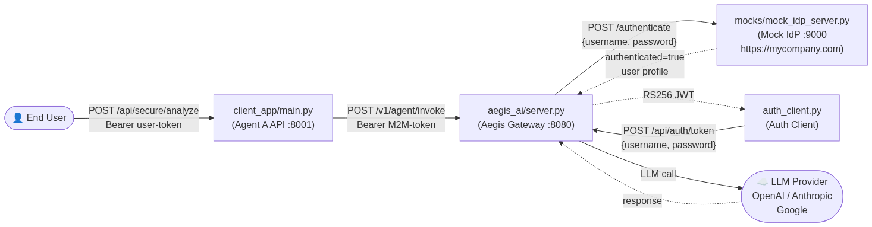
Figure 1.1: Component Interconnectivity Topology

2. Authentication Flow (auth_client.py)
The authentication client utilizes a resilient 3-step loop-engineered token exchange process. It exchanges user credentials for a cryptographically signed RS256 JWT, validates the profile context, and verifies claims introspection directly at the Aegis Security Gateway.

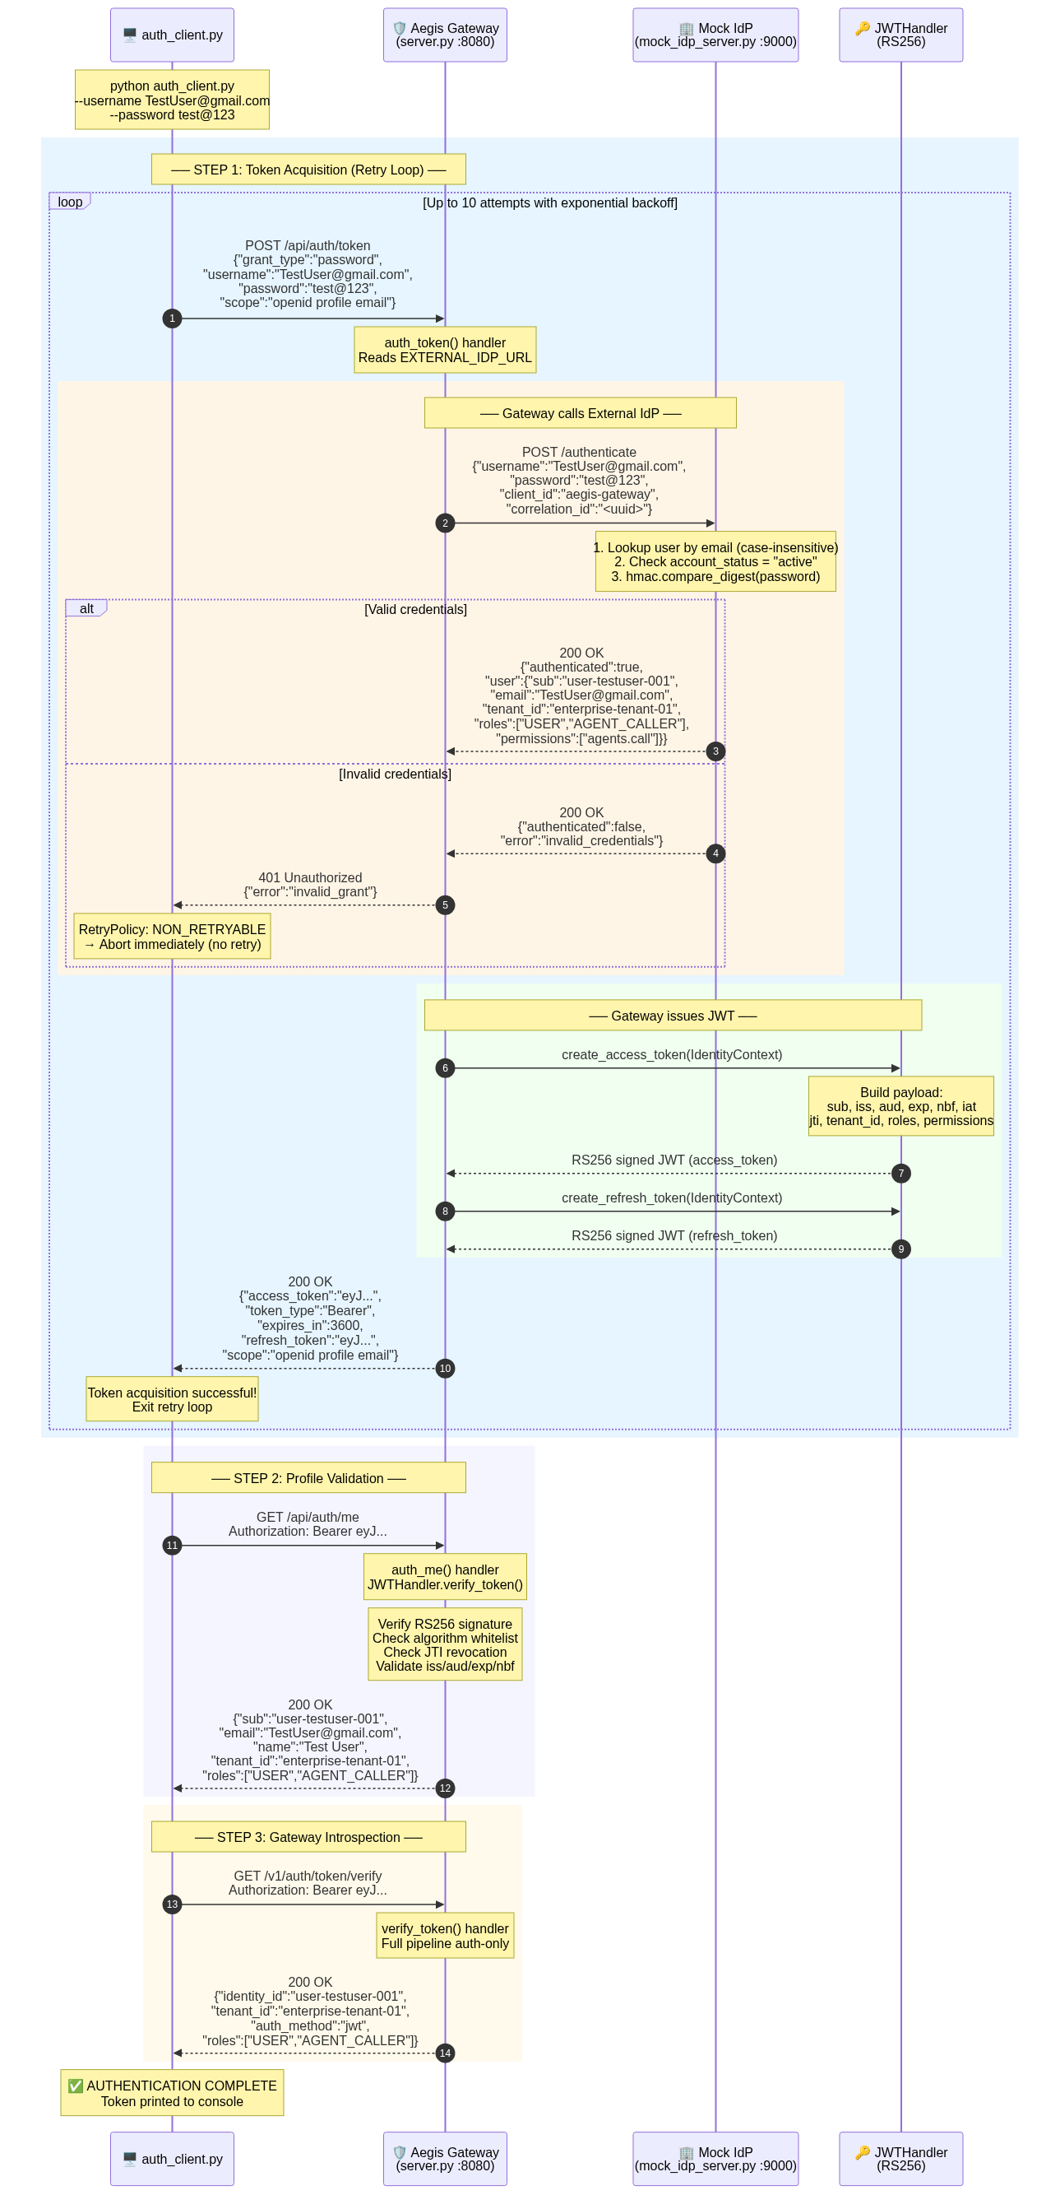
Figure 2.1: Step-by-Step User Authentication Sequence

3. Agent A Secure Analysis Flow (main.py)
The microservice (Agent A API) securely passes end-user prompts to the Aegis Gateway by validating the end-user JWT and attaching its own M2M (Machine-to-Machine) delegation token. The Gateway routes the request through a complete 9-stage EVLAS safety pipeline (Auth, AuthZ, Rate-Limiting, Guardrails, PII masking, LLM invocation, Response Validation, zero-retention compliance, and audit trail).

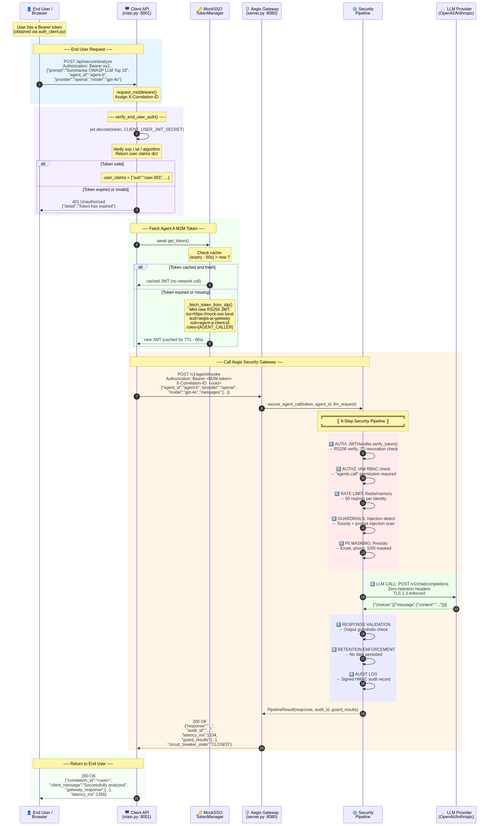
Figure 3.1: Microservice secure routing and security pipeline execution

4. Standalone CLI Agent Flow (agent_a.py)
A standalone CLI agent script that uses a stable, process-lifetime private key to generate token assertions, minimizing external handshakes while maintaining strict authorization parameters on gateway calls.

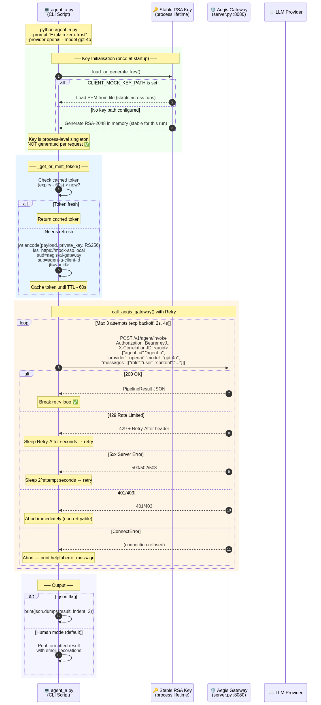
Figure 4.1: CLI Tool Key Initialisation and Gateway Ingress

5. Error Paths & Retry Policy Decisions
Describes the resilient loop-engineering logic utilized by the client adapters. Errors are separated into transient (eligible for retry with full-jitter exponential backoff) and terminal/non-retryable (aborts call chain immediately to preserve bandwidth and audit details).

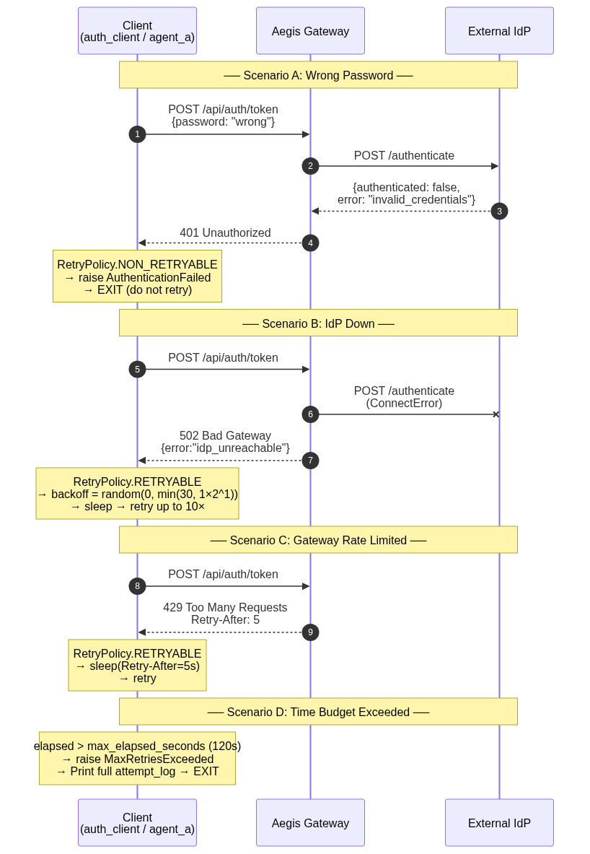
Figure 5.1: Error Handling and Backoff Strategy Matrices

